

MSP - 019

PROCEDURE FOR COMPLAINTS HANDLING & RESOLUTION

TABLE OF CONTENTS

TABLE OF CONTENTS 2
APPROVAL AUTHORITY 3
RECORD OF AMENDMENTS 4
DISTRIBUTION LIST 5
LIST OF ABBREVIATIONS 6
1. Objective 7
2. Scope 7
3. Responsibilities 7
4. Procedure 7
5. Quality Control 14
6. Related Documents 14
7. Reference Regulations & Guidelines 14
8. Related Records 14

APPROVAL AUTHORITY

Prepared by: | Quality Manager | Dr. Sai Varun  Name | Date: 14/11/2024
 |  | Signature
Reviewed & Issued by: | Laboratory Head | Dr. Abdul Aleem  Name | Date: 14/11/2024

Signature
Approved by: | Chairman & Managing Director | Mr. Venkata Cherukuri  Name | Date: 14/11/2024
 |  | Signature

RECORD OF AMENDMENTS

S. No. | Ver. No. | Ver. Date | Rev. No. | Rev. Date | Description of Changes

Document Copy No. | Name / Designation of the holder of the document copy | Type of Copy | Version No. | Revision No.
01/10 | Managing Director | Controlled Copy | 01 | 00
02/10
03/10
04/10
05/10
06/10
07/10
08/10
09/10
10/10

DISTRIBUTION LIST

LIST OF ABBREVIATIONS
S. No. | Abbreviations | Expansion
1 | BME | Biomedical Engineering
2 | CMD | Chairman & Managing Director
3 | CSD | Customer Service Department
4 | FOM | Form
5 | GE | General
6 | HR | Human Resources
7 | ISO | International Organization for Standardization
8 | MAN | Manual
9 | MSP | Management System Procedure
10 | NABL | National Accreditation Board for Testing and Calibration Laboratories
11 | QA | Quality Assurance
12 | QT QMS | Quality comes before Trust Quality Management System
13 | SOP | Standard Operating Procedure
14 | TAMS | TRUSTlab Asset Management System
15 | TAT | Turn Around Time
16 | TDPL | TRUSTlab Diagnostics Private Limited

- Objective
The purpose of this procedure is to develop a transparent system to handle and resolve complaints from internal (employees) and external (customers, contractors, suppliers, consultants) sources.
- Scope
This procedure applies to all complaints received from both internal and external sources, and is applicable to every TRUSTlab employee who receives a complaint from the said sources.
- Responsibilities
  - Quality Manager
  - Quality Assurance Department
  - CSD Manager
  - Case Officer
- Procedure
- TRUSTlab has a customer focused approach to its business and is committed to effective and efficient resolution of customer complaints. The accountability for complaints and disputes handling and reporting is part of the Customer Service Department (CSD) Manager’s tasks and activities.
- Information on all complaints and disputes is reported and tracked on a weekly, monthly and year-to-date basis. This information is reported to the Chairman & Managing Director on a monthly basis and timely resolution of all issues is a customer service key performance indicator. A number of internal reports are also created to help identify trends.
- To effectively handle customer complaints TRUSTlab adopts these five elements to ensure the best possible outcome:
- Culture
TRUSTlab has a culture of valuing complaints as a means of strengthening and improving customer relations and interactions with its customer base.
- Principles
TRUSTlab has a well-defined complaint handling system that is based on the principles of fairness, accessibility, responsiveness, efficiency and integration.
- People
CSD staff at TRUSTlab receive extensive customer service training and are well equipped to deal with a very broad range of issues.
- Process
TRUSTlab has seven stages that are used when handling a complaint. These are:
- Acknowledgement
- Assessment
- Planning
- Investigation
- Response
- Review
- Consideration of systemic issues
- Analysis
TRUSTlab uses all the information that is gathered from the complaints system as part of a continual process of improvement and organizational review.
- Receipt and Acknowledgement of External Complaints
  - TRUSTlab has made available the following avenues to its customers for registering complaints:
    - Toll free Customer Care Number: 1800 599 5656.
    - Customer/Patient Feedback Form (TDPL/CS/FOM-001)
    - Contact us through our website at www.mytrustlab.com
    - Email: csd@mytrustlab.com.
    - Postal Address: TRUSTlab Diagnostics Private Limited, Customer Service Department, #286/A, Sri Mahaan Heights, 4th Floor, Rd. No. 12, Banjara Hills, Hyderabad, Telangana 500034.
  - The availability of the above avenues of registering complaints:
    - is verbally informed to customers;
    - is set out in our Client Contract; and
    - is informed on our website.
  - Upon receipt of a complaint, the CSD Manager records it in the chronological record of all complaints received across all channels, in our QT QMS software within the Customer Complaint Module, along with all related follow-up documentation.
  - The complaint is then processed according to the following procedure:
    - Complaints are recorded and identified by a unique case number. The case record includes:
      - Date of Issue Awareness
      - Case Number
      - Designated Case Officer
      - Complainant or Customer contact information
      - Name or description of the test/process (if applicable)
      - Nature and details of the complaint
      - Dates and results of all actions and investigations, including any corrective actions
      - Any reply to the complainant or customer
      - Other relevant information, as needed
    - The case record is maintained for a period of 2 (two) years from the date of receipt.
    - Based on the nature of the complaint, the CSD Manager will route it to the appropriate department. For example:
      - Complaints related to test reports will be forwarded to the Quality Manager.
      - Complaints regarding laboratory operations will be directed to the Laboratory Manager.
      - Complaints concerning TRUSTlab employee behaviour with the customer will be escalated to the Human Resources Department.
      - Administrative complaints, such as billing errors, will be handled directly by the CSD Manager in collaboration with the responsible department.
    - As soon as a case number is generated, this information is electronically sent to the customer via WhatsApp or any other electronic communication channel they choose.
- Assess, Plan & Investigate the Complaint
- The Case Officer, in collaboration with other employees as necessary, performs the following activities:
  - Assesses, evaluates and plans the complaint case to resolution, including identification of root/likely cause based on available information. If additional information is required during the investigation process, the case officer will approach the CSD Manager who in turn will get the required additional information from the customer or other external sources.
  - The Case Officer documents all actions, investigations, immediate corrections, and corrective actions as appropriate to reflect end-to-end activity. CSD Manager will be notified of the outcomes of the investigation.
  - CSD Manager will notify the customer or other external source about the outcome of the investigation and close the complaint. For simple complaints the TAT is 2 (two) working days, however, if the nature of the complaint is complex, CSD Manager will notify the customer or other external source about the longer timeframe requirements for resolution.
- Notify, Collect Feedback & Continuous Improvement
  - Once the complaint is closed and notified to the customer or other external source, TRUSTlab will actively seek feedback on how well the complaint has been handled and the satisfaction index of the customer. First call resolution is a Key Performance Indicator for the TRUSTlab Customer Service team.
  - If the customer or other external complaint sources are not satisfied with the outcome of the complaint resolution, they are given an opportunity to escalate the issue to the Chairman & Managing Director.
- This escalation will prompt a new investigation to be carried out by a new case officer appointed by the Chairman & Managing Director. Action steps described in points 4.5.1 to 4.5.2 will be repeated.
- Where internal systemic issues are observed through the investigation process, they will be documented and presented to the Management in the Monthly Review Meetings. If the systemic issues are serious and has catastrophic effect on patient care, the documented evidence will be immediately presented to the Management and recommended actions to correct the systemic issues will be initiated.
- Receipt and Acknowledgement of Internal Complaints
- For internal complaints, employees should approach the following team members to register their complaints:
  - Human Resource Department – for all HR complaints including payroll grievances.
  - Laboratory Manager – for complaints related to laboratory operations.
  - Head of the Department – for any department clinical operations complaints.
  - BME Department Manager – for complaints related to equipment and facilities.
  - Business Head – for all other administration complaints.
- Depending on the nature of the complaint, it is registered into the appropriate software, for example, Asset complaints are lodged in TAMS, Quality related complaints in QT QMS, HR related issues in TRUSTlab’s HR software. Where there is no designated software, employees have the option of lodging the written complaints in person or via email to the designated team member.
- Complaints are recorded and identified by a unique case number. The case record includes:
  - Date of Issue Awareness
  - Case Number
  - Case Officer
  - Complainant’s contact information
  - Nature and details of the complaint
  - Dates and results of all actions and investigations, including any corrective actions
  - Any reply to the complainant
  - Other relevant information as needed.
- All the complaints are treated as confidential and will be investigated in an impartial manner.
- If the employee is not happy with the outcome of the investigation, they have the option of escalating the issue to the 2nd level by approaching the Grievance Committee with regard to any HR complaints. In the case of clinical/laboratory operations they have the option of escalating the complaint to the Laboratory Head.
- If the outcome of the second level investigation remains unsatisfactory, the third and final escalation option is the Chairman & Managing Director (CMD). Employees can lodge a formal complaint in writing to CMD. The CMD will appoint a new team to ensure the investigation is carried out independently without any influence from the previous investigation’s outcome/team members.
- The TAT for internal complaints varies depending on the nature of the complaint. The Case Officer will provide an estimated date and keep the employee up to date on the progress and, eventually, the outcome of the investigation.

Process Flow
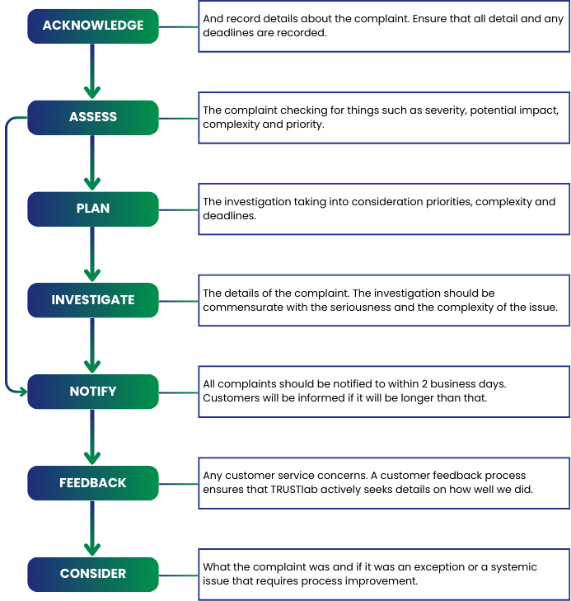
- Quality Control
The Quality Manager or designee will do random Quality Control checks to ensure that this SOP is implemented as written. If Quality control checks reveal non-compliance with this SOP, the SOP deviations and violations will be investigated, corrective and preventive action initiated, implemented, reviewed and closed out. All corrective and preventive action should be documented in the Non-Conformity & Corrective Action Form (TDPL/GE/FOM-021).
- Related Documents
N/A.
- Reference Regulations & Guidelines
  - Specific Criteria for Accreditation of Medical Laboratories (NABL 112 A; Issue 01)
  - Guidance document: Medical Laboratories (NABL 112B; Issue 01)
  - ISO 15189:2022 Medical Laboratories – Requirements for Quality and Competence
- Related Records
  - Customer/Patient Feedback Form (TDPL/CS/FOM-001)
  - Non-Conformity & Corrective Action Form (TDPL/GE/FOM-021)

